**CHAPTER FOUR**

**SYSTEM IMPLEMENTATION AND TESTING**

**4.1 Implementation**

Framework Nowadays, many frameworks have been developed for deep learning. Some of the most popular ones include libraries such as: OpenCV, TensorFlow. Also, implementing a framework from scratch using a programming language was never considered. It would have been out of scope since it requires a big amount of effort, and the duration of such a project usually takes years. The use of Java as the front-end API on all these frameworks shows that it is the preferred language for machine learning. Usually, Java is combined with a programming language that provides support for low level operations such as: C or C++, to act on the back end.

**4.2 Frameworks**

**4.2.1 TensorFlow:** TensorFlow (TF) is an open source software library for machine learning written in Python and C++. Its release some months ago (Nov 15) had a strong press coverage. The main reason behind it is that TF was developed by Google Brain Team. Google has already been using TF to improve some tasks on several products. These tasks include speech recognition in Google Now, search features in Google Photos, and the smart reply feature in Inbox by Gmail.

**4.2.2 OpenCV**: OpenCV is a library of programming functions mainly aimed at real-time computing.

**4.2.3 Apache Netbeans:** bean, Java Development Environment, is a free integrated development environment (IDE) that is included with multiple frameworks. It includes editing, interactive testing, debugging, and introspection features

**4.3 Implementation Details**

This system that was developed and built in Java with OpenCV framework which incorporated with powerful compilers for smooth and efficient running of Java programs. Java programming language was chosen as the best language of choice for this particular program, this was observed as a result of java being the most efficient and typed programming language in image processing or computer vision task. Difference libraries were required to incorporate with the system such as OpenCV, TensorFlow, and etcetera. For this reason a lot of libraries were used for letting the program become success.

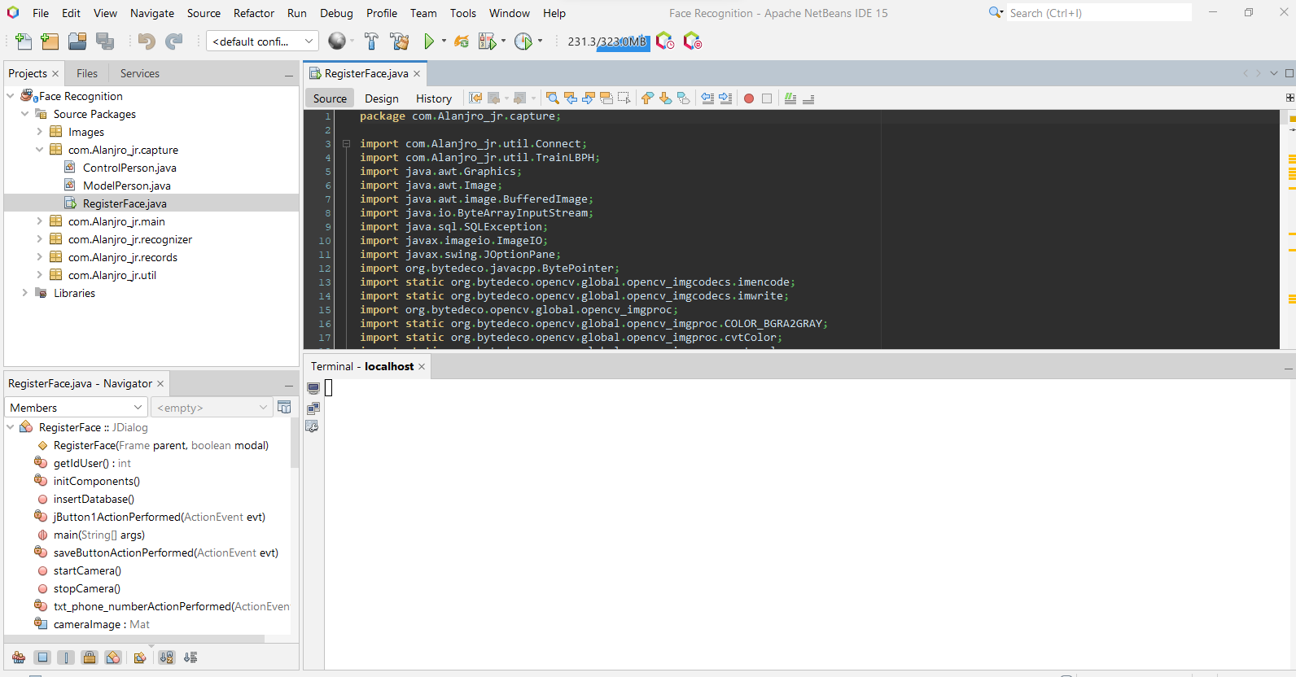

**Fig 4.0 Netbeans IDE Screen**

This is the interface of “Apache Netbeans” which include Powerful compilers and as one of the compiler which simplify the works of computer vision

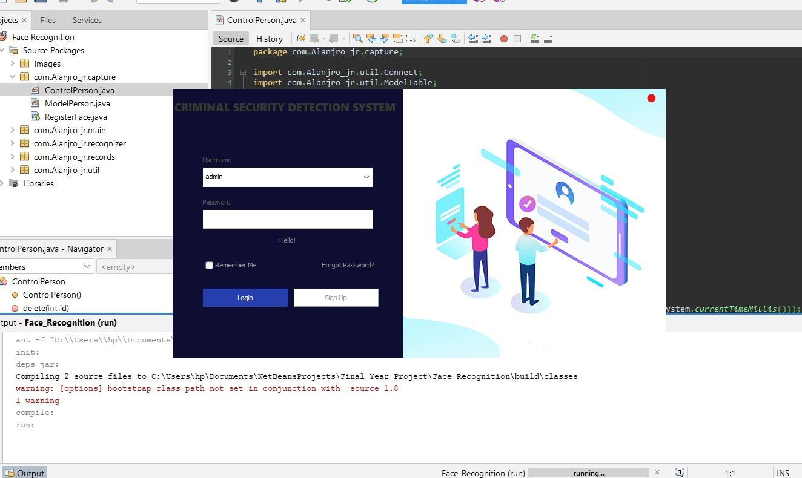

**Fig 4.1 Login Screen**

The login authorization page of a Face Recognition Security System serves as the initial access point, ensuring secure entry into the system. Users are required to authenticate themselves, adding an extra layer of security.

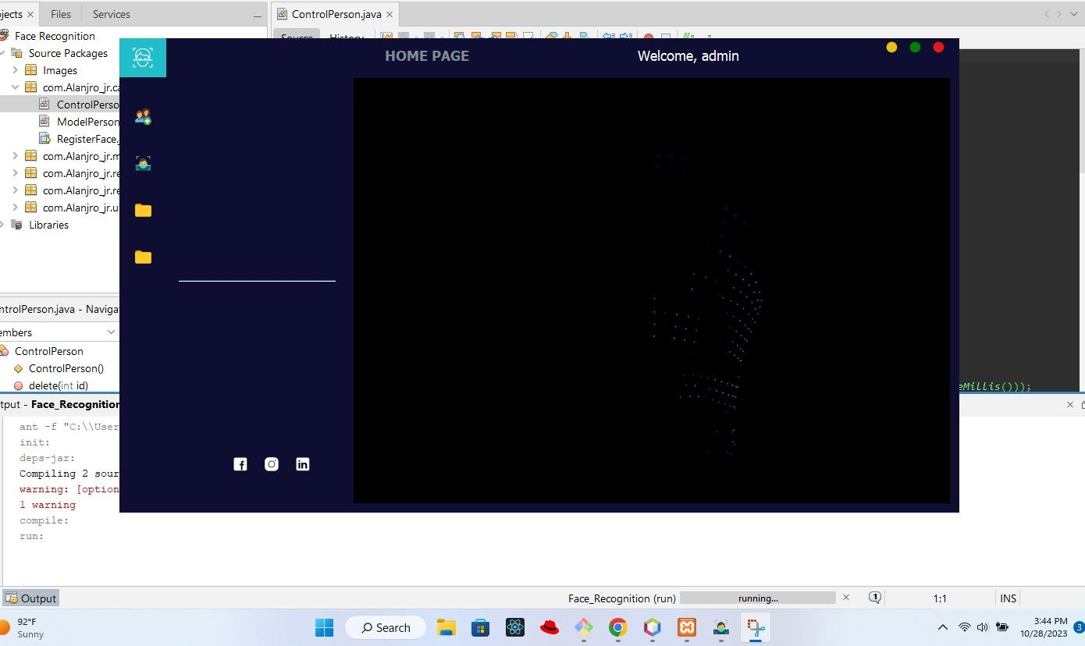

**4.2 Administration Dashboard**

The homepage of the Face Recognition Security System features user-friendly options for New Enrollment, the Recognizer Page for quick identity verification, and a centralized Data or Registered Faces Page for convenient management of stored facial data.

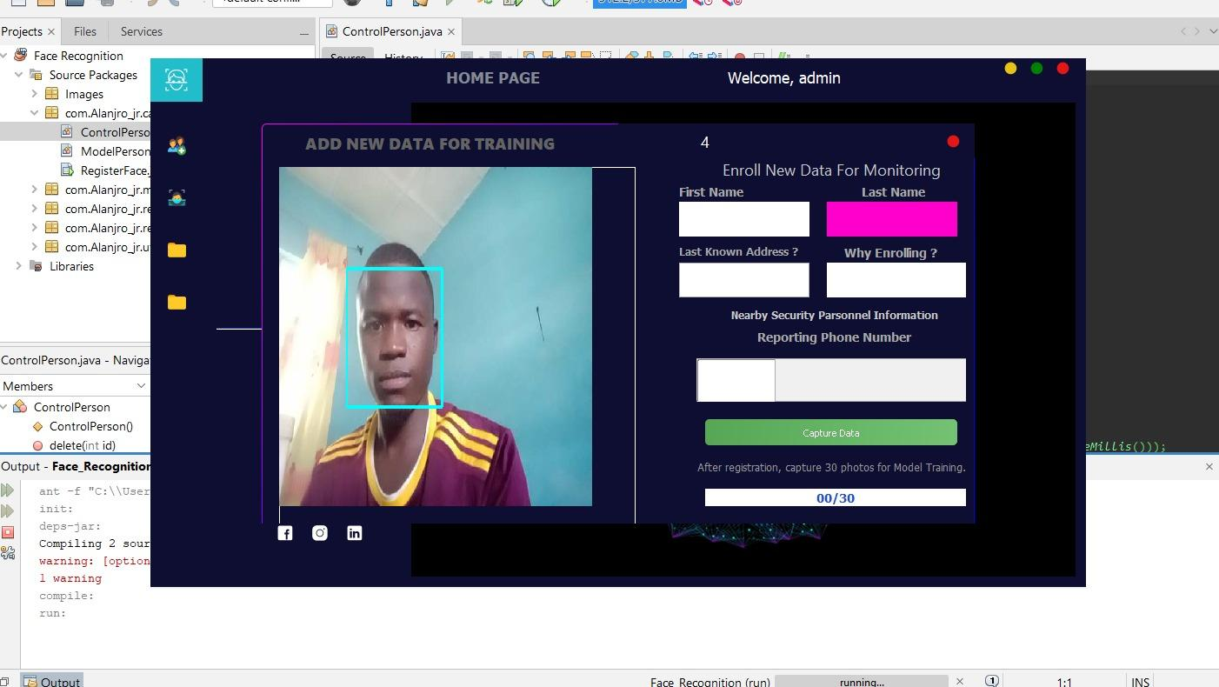

**4.3 User/Client Enrollment Page**

The Enrollment Page of the Face Recognition Security System incorporates essential Client details, including the client's name and the reason for registering, along with an option to provide a nearby security contact number. Additionally, the page allows for live photo capture through the webcam, ensuring real-time facial data input, and includes a convenient "Save" button for secure storage and registration.

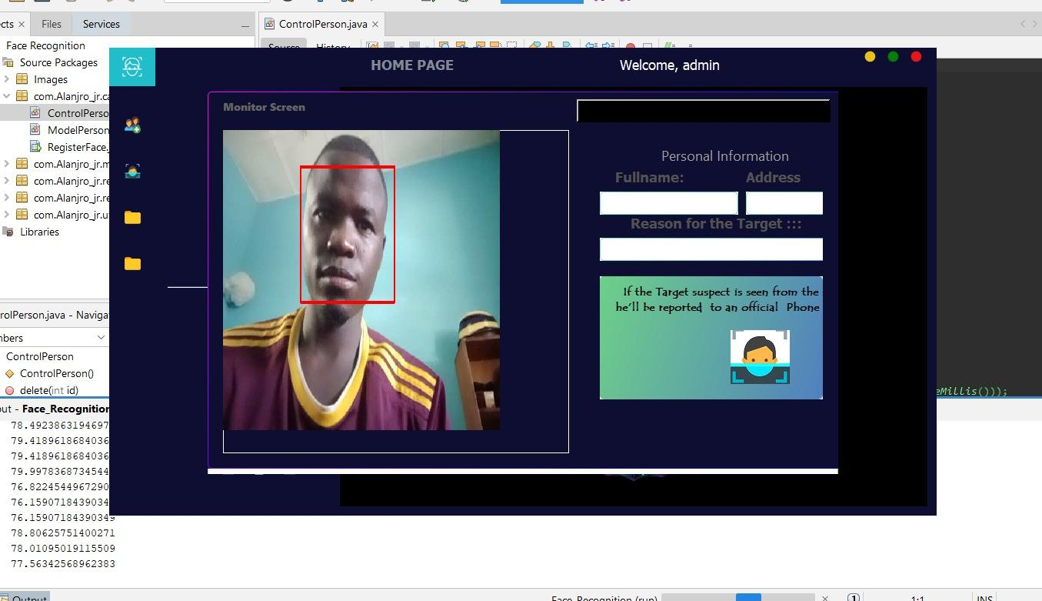

**Fig 4.4 Recognizer Page**

The Recognizer Page of the Face Recognition Security System displays key information, including the recognized individual's name and photo. It features an SMS notification functionality to alert Nearby Security Personnel. For visual clarity, a green box surrounds the image for recognized faces, while a red box indicates unrecognized individuals, enhancing quick and intuitive identification.

**CHAPTER FIVE**

**SUMMARY, CONCLUSION AND RECOMMENDATION**

**5.1 Summary**

The research focuses on the creation of a security system that utilizes facial recognition technology for enhanced security. The system is designed to recognize and verify individuals based on their facial features. When an unauthorized individual is detected, the system sends a notification via SMS to alert relevant authorities or designated personnel.

The key components of this research involve:

1. Facial Recognition Technology: The study explores the implementation of facial recognition algorithms to accurately identify individuals by analyzing facial features.
2. Security System Integration: The developed system is integrated into security infrastructure, such as access control systems, surveillance cameras, or entry points, to enhance security measures.
3. SMS Notification: Upon detecting an unauthorized individual, the system triggers an SMS notification to inform security personnel, allowing for a prompt response to potential security breaches.

The research likely includes the design and development of the software and hardware components, testing for accuracy and reliability, and an evaluation of its effectiveness in enhancing security. The system's potential applications could range from access control in buildings to border security or any environment where facial recognition can play a crucial role in safeguarding assets or individuals.

**5.2 Conclusion**

Face recognition systems basically belong to the category of image processing application and their importance is increasing fairly regularly. Mostly, these kinds of systems have applications in surveillance, personal verification and some other related security activities.

The proposed system utilized the concept of facial recognition by using a pre-trained LBPH Face Recognizer to identify the person in the acquired frame.  System mounted camera captured the live video stream. A module processed the acquired video information. The system can detect the desired person with the accuracy of 89.1%. If we further increase the number of datasets, then the accuracy will also increase.  We could also update the concerned authorities about the culprits’ location at the same time using a mounted SMS module. The proposed system can prove most beneficial to improve the existing security system.

**5.3 Recommendation**

Recommendations for the research may include the following:

1. Security and Privacy Considerations: Ensure that the system complies with privacy regulations and ethical considerations. Implement measures to protect the privacy of individuals whose facial data is being captured and stored.
2. Testing and Validation: Conduct rigorous testing and validation of the facial recognition algorithms to ensure high accuracy and low false positive rates. Real-world testing in various lighting and environmental conditions is essential.
3. User-Friendly Interface: Design an intuitive and user-friendly interface for system administrators and end-users. This will make it easier for personnel to manage and interact with the security system.
4. Redundancy and Fail-Safes: Incorporate redundancy and fail-safe mechanisms to prevent system failures. Implement backup systems and alternative security measures for cases of technical issues or system malfunctions.
5. Data Security: Safeguard the facial recognition data with robust encryption and access control measures to prevent unauthorized access or data breaches.
6. Scalability: Ensure the system can be easily scaled to accommodate additional users, devices, or security areas. This is important for organizations that may need to expand their security coverage.
7. Integration with Existing Systems: Make the system compatible with existing security infrastructure, such as surveillance cameras and access control systems, to maximize its effectiveness and utility.
8. Regular Maintenance and Updates: Establish a maintenance schedule and update plan to keep the system up-to-date with the latest security and facial recognition technologies.
9. Training and Awareness: Provide training for personnel responsible for using and managing the system to ensure they are proficient in its operation and understand the importance of maintaining privacy and security standards.

These recommendations should help ensure the successful implementation and ongoing effectiveness of the facial recognition security system with SMS notification while addressing ethical, legal, and technical considerations.